What Is An Altered Book???

Name_____________________Due Date:_________________
The International Society of Altered Book Artists (http://www.alteredbookartists.com) defines an altered book as, "any book, old or new that has been recycled by creative means into a work of art.” It is simply a book which has been “Altered”(changed) into a piece of ART by painting, drawing, gluing items on, stamping, or beading over the print, collaging onto the pages or cutting a niche and putting items into it.
You will pick a “just-right” book to read from the list I provide, then create an “Altered Book.” There are no rules (but there are requirements) when making an “Altered Book.” The pages can be cut, folded, glued together, and you can cut niches into the book. The pages can be covered with fabric, polymer clay, textile pieces and pockets. You may also put hidden messages in your “Altered Book.” The main thing is to have fun and let your creative side out!
Your “Altered Book” must include the following. YOU MUST INCLUDE TABS THAT INDICATE THE LOCATION OF EACH REQUIREMENT:
- Cover: Design a new cover representing your novel selection.
- Title Page: Make a new title page. Include: Title, Author (Illustrator if applicable), Student Name, and Class Period
- “Black out Poetry”: Include at least two examples of “black out poetry” on a theme/topic from the novel. You will black out sections of a page of text leaving some words exposed to create a poem.
- Summary: Include a summary page- central idea + details (7-9 Sentences).
- Quotes: Two pages of five (5) selected quotes from the novel (10 total). You must include:
  - Who stated the quote
  - What was compelling about each quote
  - The quote’s impact on the plot of the story
- Collage: Two full collage pages using words/pictures to represent themes from your novel (must cover the entire page).
- Plot Diagram: Plot the major events from the novel [Exposition, Rising Action (3-4 key episodes), Climax, Falling Action (3-4 key episodes), and Resolution].
- Test Questions: Create 10 Blooms’ style questions about the reading, and include an answer key. Blooms’ Taxonomy question stems can be found on the back of this page.
- Character Development Graphic Organizer: Choose two characters and create a graphic organizer for each one. You must include character development based on the character’s actions, thoughts, and sayings.
- Analogies: Create five different analogies using aspects from the book. Examples of analogies can be found at: https://www.greenwichschools.org/uploaded/north_street/pta/WordMasters/AnalogiesRelationships.pdf
- Reflection: A reflection page on your thoughts regarding the reading, as well as the author’s point-of-view and purpose (7-9 sentences).
- Theme, Figurative Language, or Mood/Tone: Choose two topics (theme, figurative language, or, an example of mood/tone presented in your book), then create a page for each. Be creative with these pages!
Theme- describe the theme found in the novel. Provide textual evidence to support your explanation.
Figurative Language- Give 3 examples of figurative language, and explain their impact on the story. (***Say more than “The author included figurative language to add impact.”)
Mood/Tone- Explain and illustrate the mood and tone found in a section of the novel. Provide an excerpt that demonstrates your explanation. (Suggestion: Wordle or Drawing)

Blooms’ Question Stems
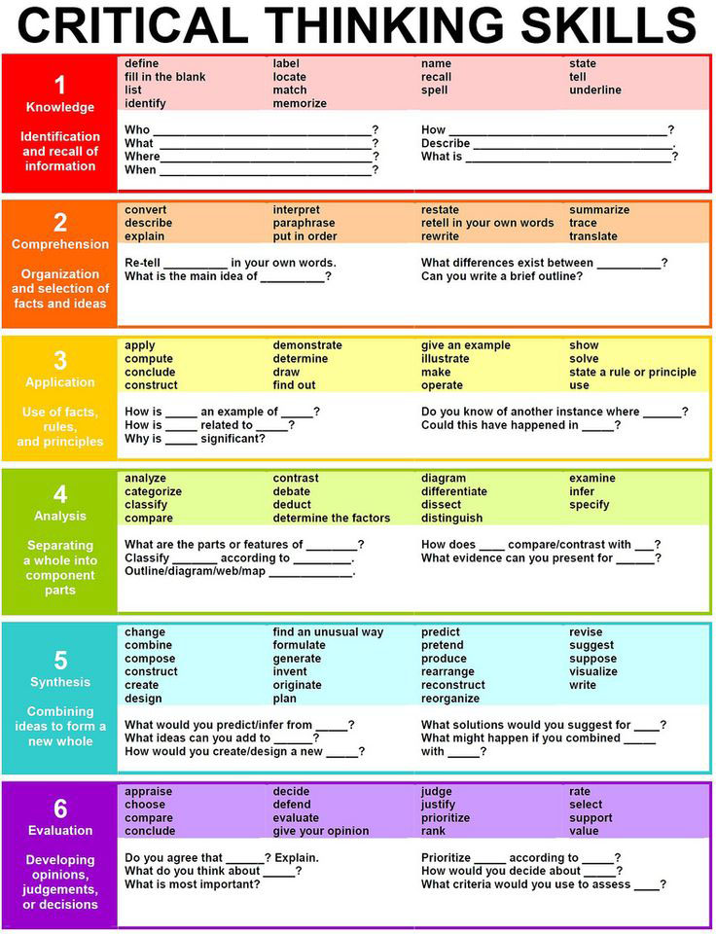

Source: http://www.teachthought.com/critical-thinking/blooms-taxonomy/25-question-stems-framed-around-blooms-taxonomy/

Novel List

Red Badge of Courage by Stephen Crane

Call of the Wild by Jack London
Bud, Not Buddy by Christopher Paul Curtis

The Wednesday Wars by Gary D. Schmidt

Freak the Mighty by Rodman Philbrick
Roll of Thunder, Hear My Cry by Mildred D. Taylor
Esperanza Rising by Pam Munoz Ryan

Tuck Everlasting by Natalie Babbitt
Scat by Carl Hiaasen
Wonder by R. J. Palacio
Loser by Jerry Spinelli
The Lightning Thief by Percy Jackson
Holes by Louis Sachar
Miracle’s Boys by Jacqueline Woodson
Locomotion by Jacqueline Woodson

Rubric
Name:________________________ Pd:________
 | 25-22 points | 21-18 points | 17-14 points | 13 points and below
Requirements  * See page descriptions above! | Included 11-12 requirements | Included 9-10 requirements | Included 7-8 requirements | Included less than 7 requirements
Quality/Neatness | All pages are:  - Colorful  - Neatly glued or attached  - Typed or written with a device that is not a pencil. | Most* of the pages are:  - Colorful  - Neatly glued or attached  - Typed or written with a device that is not a pencil. | Some* of the pages are:  - Colorful  - Neatly glued or attached  - Typed or written with a device that is not a pencil. | All of the pages:  - Have no color  - Included text that was written with a pencil  - Were sloppy
Content | The required aspects fully reflect comprehension of the novel selected. | The required aspects closely reflect comprehension of the novel selected. | The required aspects partially reflect comprehension of the novel selected. | The required aspects do not reflect comprehension of the novel selected.
Due Date | Project was turned in on the due date | The “Late Policy” will apply if the project is not turned in on the due date.
* Based on teacher’s judgement

Total Points: _________ out of 100.

