Name______________________________________________________________________Date:

Three Wishes
Once there lived a woodcutter with his wife. He used to cut wood in the forest and sold them in the market. This was the only means of his livelihood.
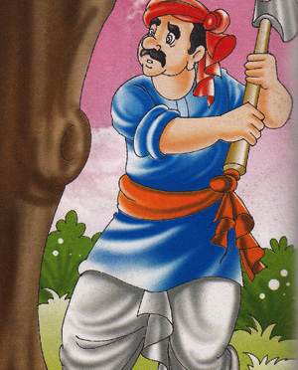
One day, he went to cut wood in the forest. On the way, he was singing a song and enjoying the nature and its beauty. There he saw a very big tree in front of him. He thought of cutting the whole tree to get more wood. As the tree was very big, the wood obtained from it would be enough for his whole life.
As the woodcutter picked up his axe to cut the tree, he heard a voice, "Please do not cut this tree." The woodcutter stopped and looked here and there, but found none. He thought it to be an illusion. He again picked his axe and aimed at the tree, but he heard the same words again, "Please be kind to me. Do not cut this tree." The woodcutter again stopped and looked all around. But he could not see anyone. He was quite perplexed. Then a fairy spoke from the tree, "I am a fairy and live in this tree. During the winter, I live in the trunk and for rest of the year I live on its branches. If you cut this tree, I will be homeless, the winter is approaching fast and I will die of cold. Do not destroy my home. I will fulfill your three desires instead."
The woodcutter was very happy. Now he could be rich without doing any work. He accepted the fairy’s offer and ran to his house to tell his wife about this. His wife was waiting for him as usual. She was surprised to see the woodcutter back so early and said, "Why did you so early today? You are looking very happy. What is the matter? Please let me know."
The woodcutter replied, "I got a big treasure today. Though it is yet to come. I will get the treasure soon." And he started dancing. His wife could not understand anything and said, "What is the matter? Tell me clearly. I cannot hold my patience anymore."
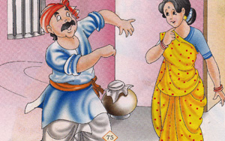
The woodcutter narrated the whole incident to his wife. His wife jumped out of joy. The woodcutter said, "I am hungry. Give me something to eat." His wife said, "Since you used to come late, I have not prepared anything till now. Wait, I will just prepare something for you." The woodcutter said, "No, do not cook anything. I can fulfill any three desires. Now as the first one, I want sweets and hot pudding." As soon as he uttered these words, a plate of hot pudding came before him. He ate to his satisfaction and the plate continued to fill again and again. Then he asked his wife also to eat the tasty pudding. But she was very angry and said, "You have wasted one boon, and now I wish that the pudding should be pasted on your nose!" The pudding immediately stuck to his nose. The woodcutter got annoyed and said, "Oh, what a fool you are! What have you done?" He tried to clear the pudding from his nose, but the pudding remained stuck. He scolded his wife and said, "You have wasted the second boon and we can ask for lots of money." I wish that the pudding of my nose should vanish immediately!" The pudding vanished. The woodcutter heaved a sigh of relief.
This way, the woodcutter and his wife lost the golden opportunity of becoming rich. Their luck had knocked at their door, but they failed to avail the opportunity and remained poor as before.

