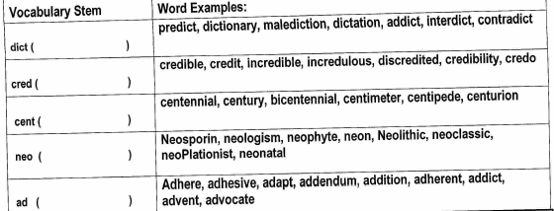
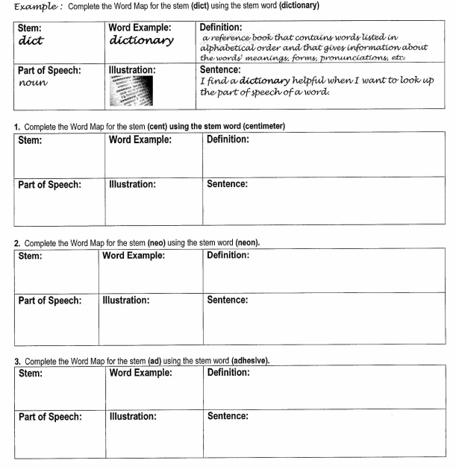
Vocabulary Stem Homework: Word Maps + Tic Tac Toe: Due Friday 1/20

